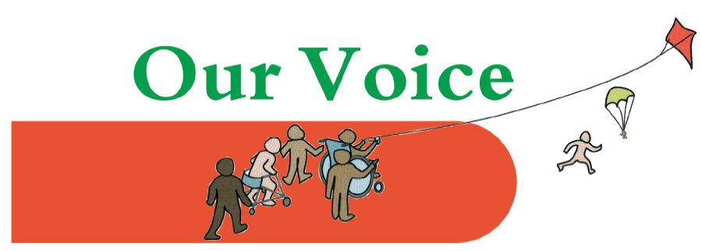

Vaccinations – information and Q&A session for parents/carers

Monday 4th October from 11 am to 12 noon (online)

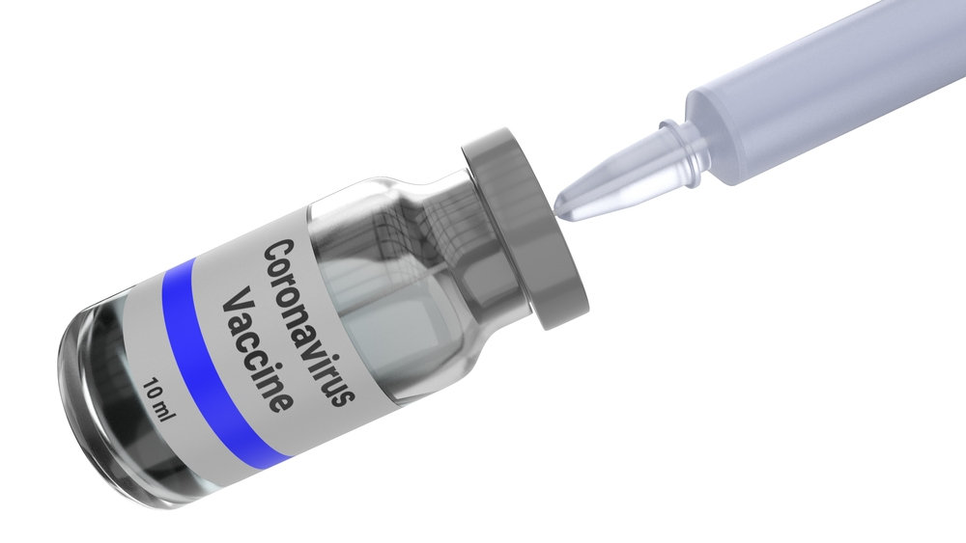
This videoconference session, organised by Our Voice Parent/Carer Forum, is for all parents and carers of children and young people (aged 0-25) with special needs and/or disabilities, living in Enfield.

We will be focusing on children aged 12 – 15 who are now being invited for the Covid -19 vaccination

The meeting will take place online via Zoom. The event is free but you must pre-book here.
This information and Q&A session regarding vaccination, for parents and carers of children and young people with SEND. We will be updated about the roll-out of Covid-19 vaccines to children and young people aged 12-15, as well as booster jabs for family carers. We will be looking at the general arrangements and specific arrangements for children who have learning difficulties or neuro-diverse conditions such as Autism, the issues for children with health conditions and allergies and how best to prepare your child for the vaccination.
This will be followed by an open Q&A session when you will have the opportunity to ask any additional questions you may have regarding vaccination. The panel will include:
Duduzile Sher Arami: Acting Director, Public Health, Enfield
Belinda Danso-Langley: Neurodevelopmental Community Paediatric Service Lead
Please submit any questions in advance, either using the booking form or emailing us at info@ourvoiceenfield.org.uk by Friday 1st October at the latest. If time permits, we will also look at any additional questions submitted during the event.

