This is my
Hospital Passport
For people with learning disabilities coming into hospital
My name is:
If I have to go to hospital this book needs to
go with me, it gives hospital staff important
information about me.
It needs to hang on the end of my bed and a
copy should be put in my notes.
This passport belongs to me. Please return it when I am discharged.
Nursing and medical staff please look at my passport
before you do any interventions with me.
Things you must know about me
Things that are important to me
My likes and dislikes

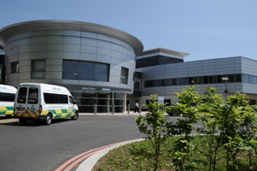
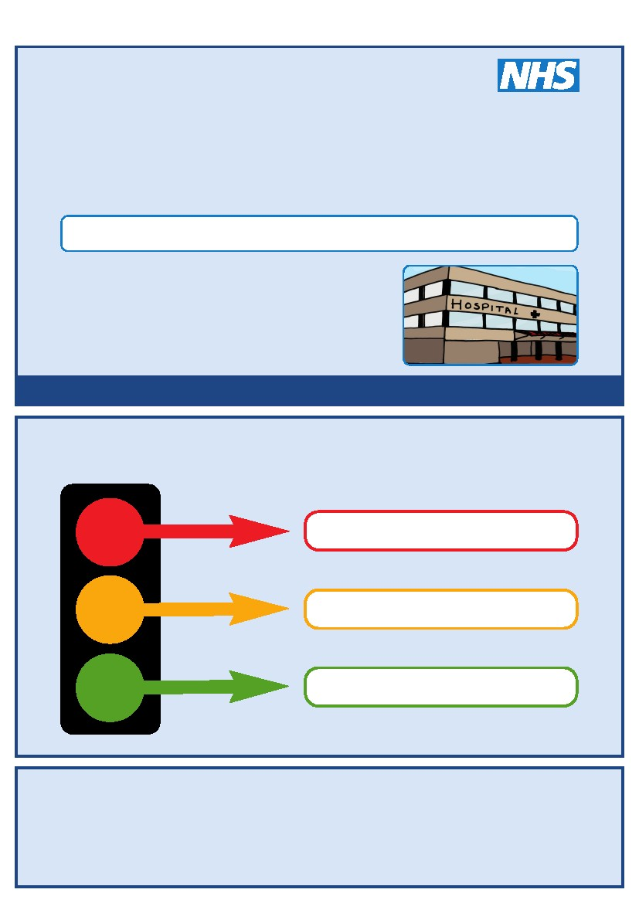
If I am assessed as lacking the capacity to consent to my treatment the following people must be involved in best interest’s decision making
Name Relationship Contact Details
Name Relationship Contact Details
Name Relationship Contact Details
Name Relationship Contact Details

Mental Capacity Act 2005
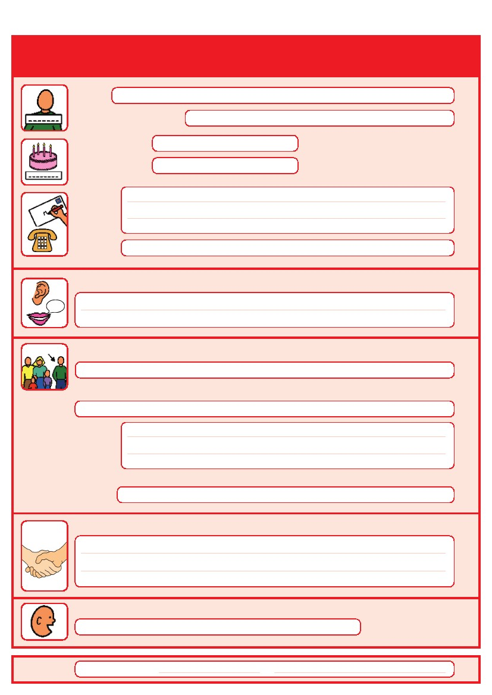
Things you must know about me
Name:
Likes to be known as:
NHS number:
Date of Birth:
Address:

Tel No:
How I communicate/What language I speak:

Family contact person, carer or other support:

Relationship e.g. Mum, Dad, Home Manager, and Support Worker:

Address:

Tel No:
My support needs and who gives me the most support:

My carer speaks:

Date completed
By
1

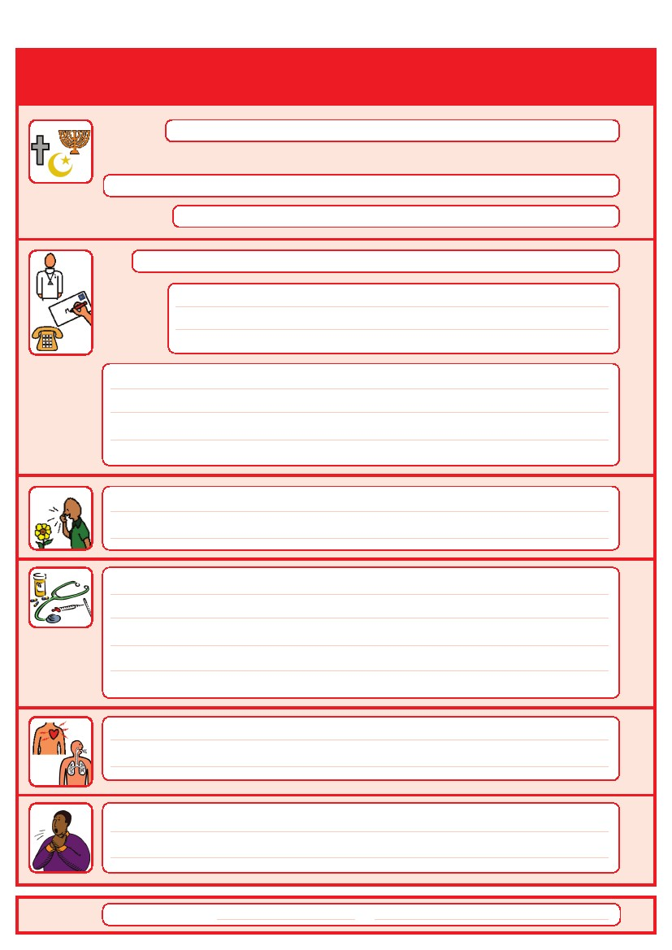
Things you must know about me
Religion:
Religious/Spiritual needs:

Ethnicity:
GP:
Address:

Tel No:
Other services/professionals involved with me:

Allergies:

Medical Interventions – how to take my blood, give injections, BP etc.

Heart
Breathing problems:
Risk of choking, Dysphagia (eating, drinking and swallowing):

Date completed
By
2

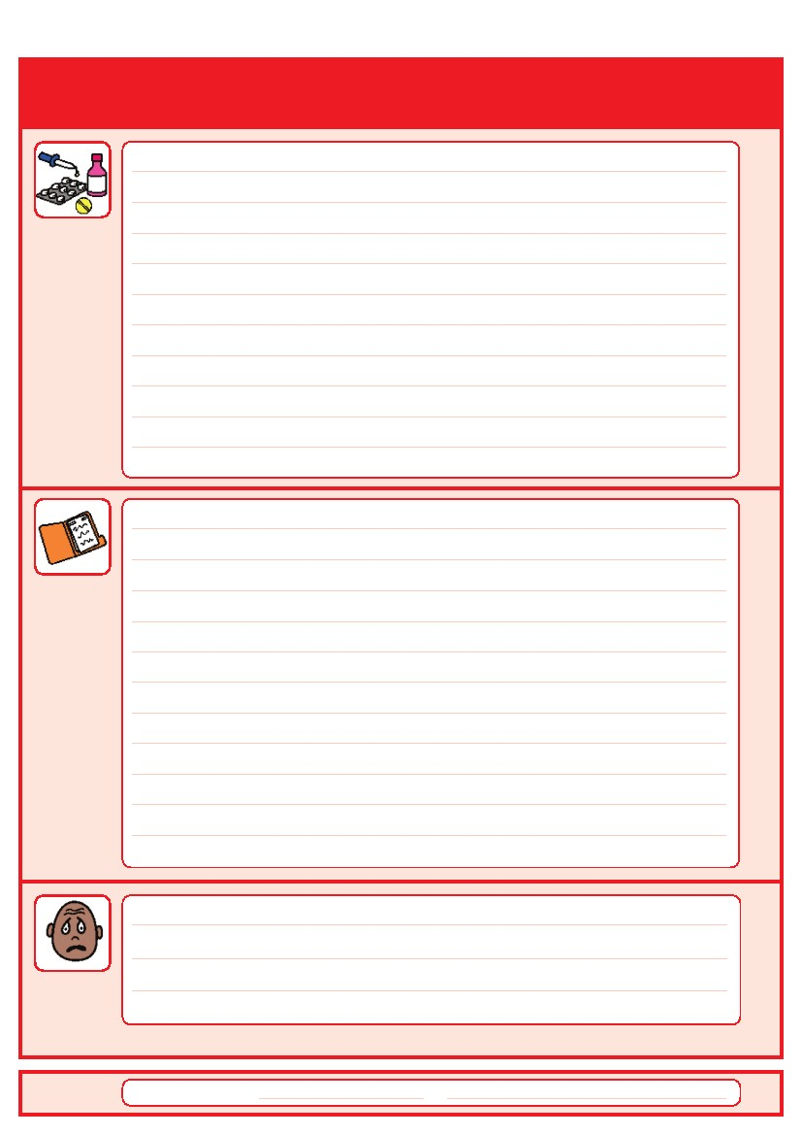
Things you must know about me
Current medication:

My medical history and treatment plan:

What to do if I am anxious:

Date completed
By
3

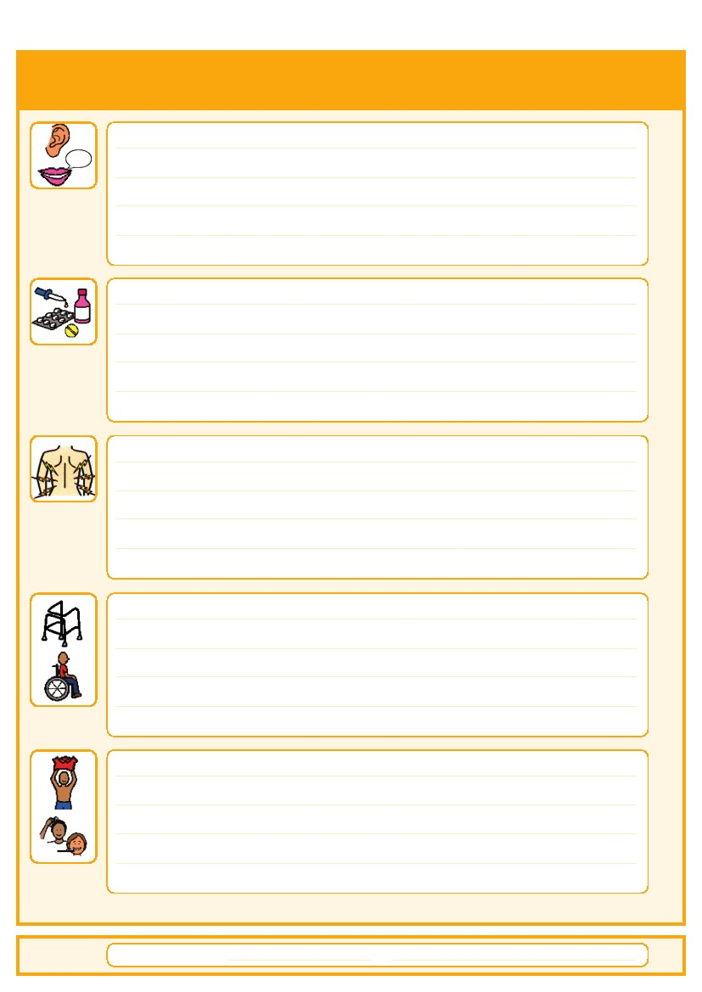
Things that are important to me
How to communicate with me:

How I take medication: (whole tablets, crushed tablets, injections, syrup)

How you know I am in pain:

Moving around: (Posture in bed, walking aids)

Personal care: (Dressing, washing, etc)

Date completed
By
4

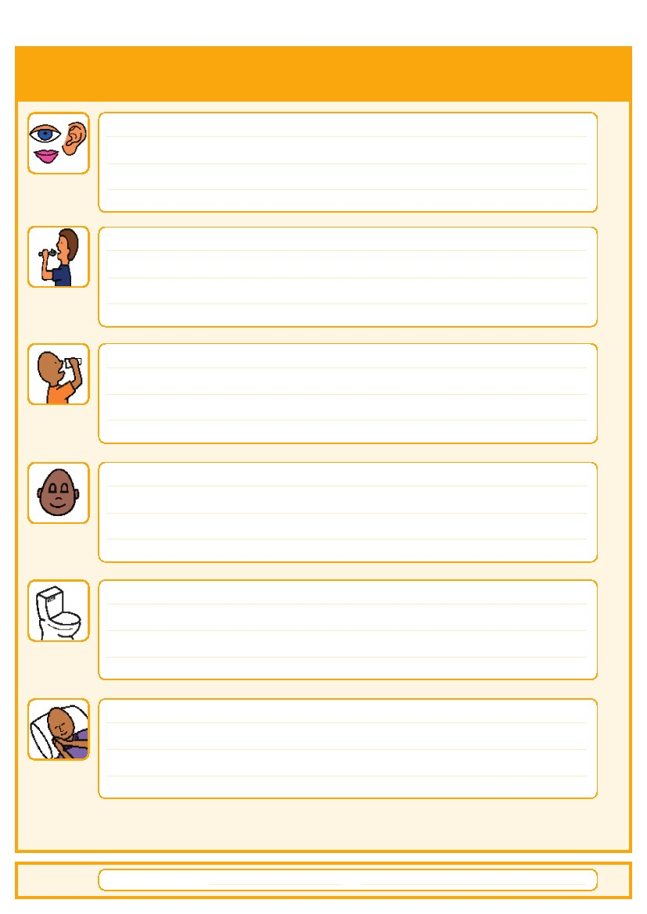
Things that are important to me
Seeing/Hearing: (Problems with sight or hearing)

How I eat: (Food cut up, pureed, risk of choking, help with eating)

How I drink: (Drink small amounts, thickened fluids) no problem

How I keep safe: (Bed rails, support with challenging behaviour)

How I use the toilet: (Continence aids, help to get to toilet)

Sleeping: (Sleep pattern/routine)

Date completed
By
5

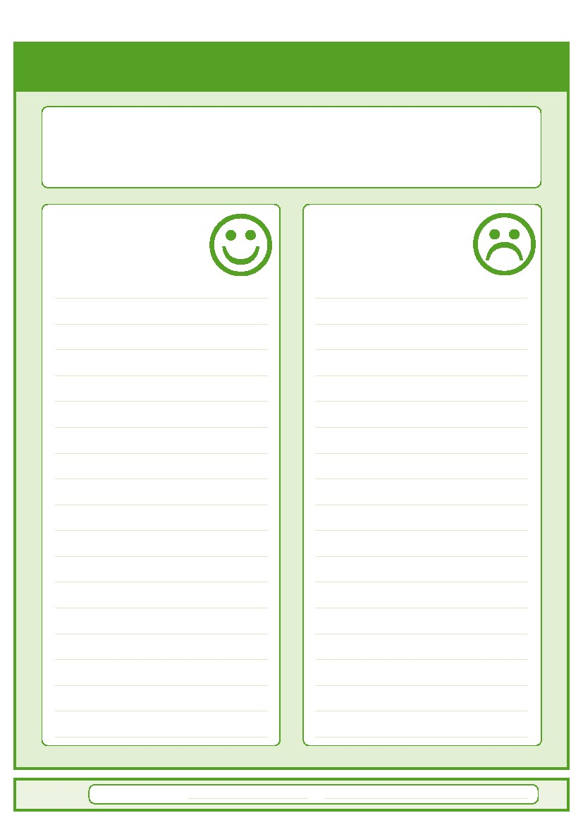
My likes and dislikes
Likes: for example - what makes me happy, things I like to do
i.e. watching TV, reading, music, routines.
Dislikes: for example - don’t shout, food I don’t like, physical touch.
Things I like
Please do this:
Things I don’t like
Don’t do this:
Date completed
by
6

Notes – including information about my weekly activities

7

Contacts and useful websites
Community Learning Disability Teams (CLDT)
Barnet Learning Disability Service
020 8359 6161/6160
BLDS.dutydesk@barnet.gov.uk

Enfield Integrated Learning Disability Team
020 8379 5039
Learning.disabilities@enfield.gov.uk
Hertfordshire Health Access Team
01442 454315
Haringey Learning Disability Partnership
020 8489 1384
Islington Learning Disability Partnership
020 7527 6600

Camden Learning Disability Service
020 7974 3737

www.easyhealth.org.uk
www.intellectualdisability.info

www.IHAL.co.uk
www.mencap.org.uk/gettingitright
8
Please contact your local community learning disability team
if you have any questions about the passport
This Hospital Passport was developed by the South West London Access to Acute Group and based
on original work by Gloucester Partnership NHS Trust.
Thank you to The Baked Bean Theatre Company, members of our community, Wandsworth
Community Learning Disability Team, members of the St Georges Access to Acute working party,
Merton CTPLD Community Nurses and the Corporate Design department at Wandsworth Council who
all inputted into the redesign of this document.
AS.42a (12.09)

