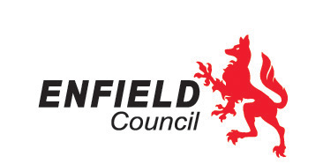
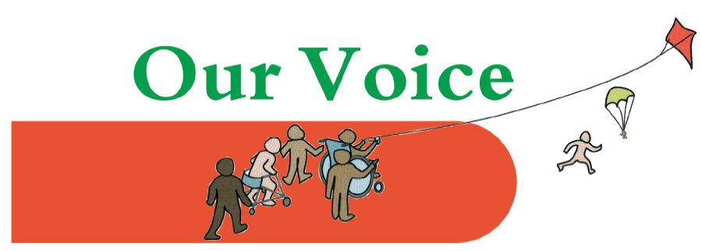

Introduction to Positive Behaviour Support for parents and carers

This workshop, organised by Our Voice Parent/Carer Forum and Enfield’s Joint Service for Disabled Children, is for all parents and carers of children and young people (0-17) with special educational needs and/or disabilities living in Enfield.
The training aims to provide an understanding of Positive Behaviour Support, to help families to prevent and manage behaviours of distress, by creating an environment where the behaviour is no longer needed and so to improve the quality of life for their child or young person and the whole family. We will look at how families can work with the network of people around their child or young person (such as staff at their school or social care environments) to enable a consistent approach that encourages engagement in education and the community.
The training is delivered by expert Our Voice team members with lived experience and promotes strength-based approaches and a truly person-centred approach.
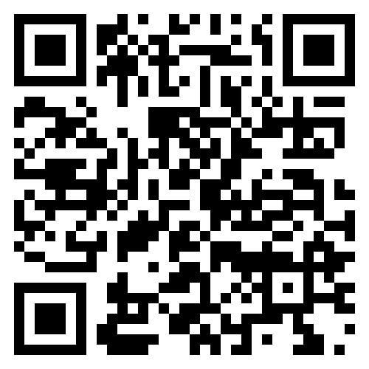
Dates:
- 22nd May 2024
- 12th June 2024
- 26th June 2024
You only need to attend one session.
All sessions are 10 am – 12 pm at Cheviots, 31 Cheviot Close, Enfield, EN1 3UZ
Book your place at
https://OV-PBS-intro.eventbrite.co.uk
If you require an interpreter and/or childcare to support you to attend this training please state this in your booking form.
Scan QR code to book

Our Voice will also be supporting professionals from the Cheviots team at drop-in sessions where you can discuss specific questions regarding your child’s behaviour. See details on our website at https://www.ourvoiceenfield.org.uk/events

