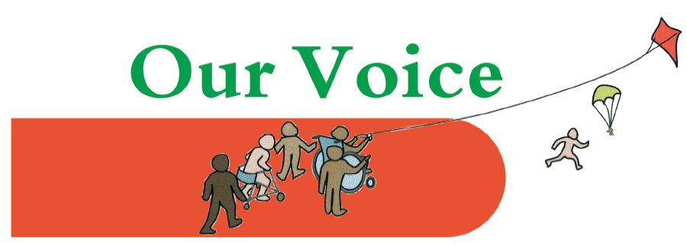
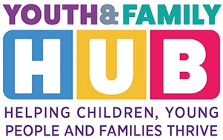
Our Voice drop-in service
For parents/carers of children & young people aged 0-25 with Special Educational Needs/ Disabilities

At the Ponders End Family and Youth Hub
Ponders End Youth and Family Hub
129, South Street, Enfield, EN3 4 PX
(next to Oasis Hadley Academy)
Drop in – no need to book
An opportunity to talk to one of the parent carers from the Our Voice team about any questions you may have, and to chat with other parents of children with additional needs.

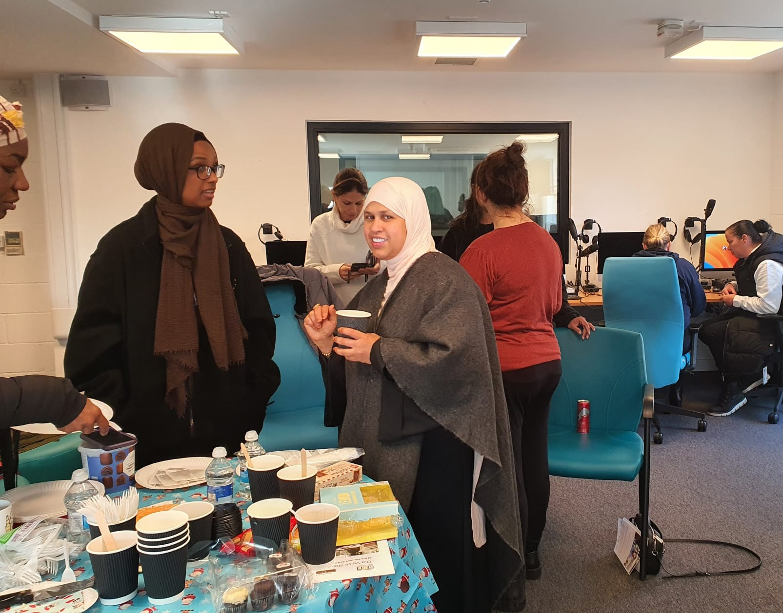
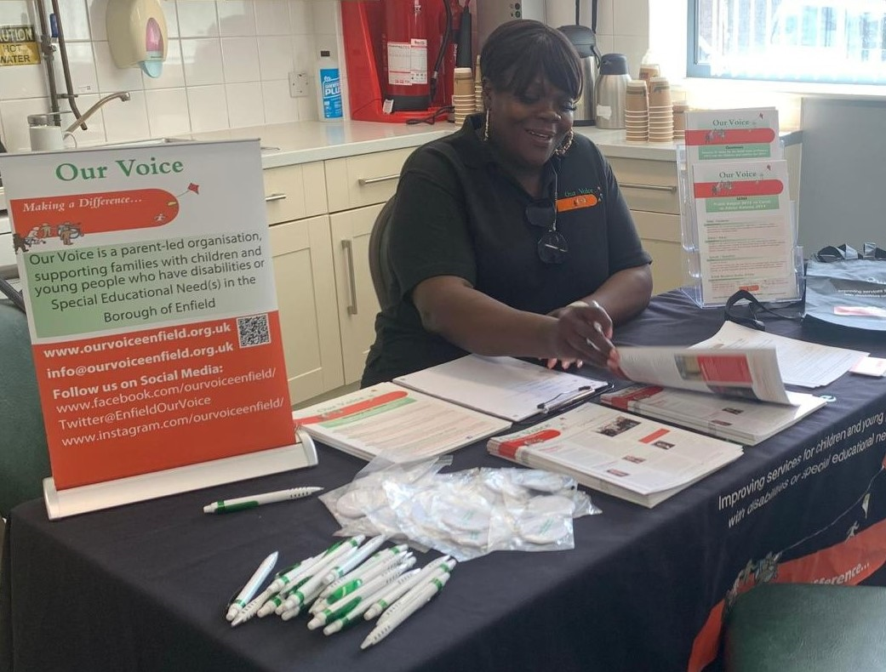
Join members of the Our Voice team for our regular drop-in sessions at the Youth and Family Hub in Ponders End.
Wednesday 5th June | 10 am – 12.30 pm
Wednesday 3rd July | 10 am – 12.30 pm

See the Our Voice events page for more information and further dates.
https://www.ourvoiceenfield.org.uk/events

Our Voice is the official parent carer forum supporting the families of children and young people aged 0 -25 years with Special Educational Needs or Disabilities, living or attending school in the London Borough of Enfield. We are not part of the Local Authority but we work with them to improve services for the families that we represent.

