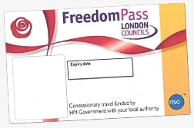
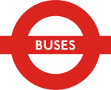

FIRST ROUTE ENFIELD

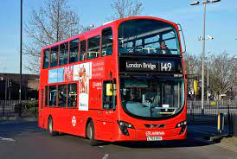
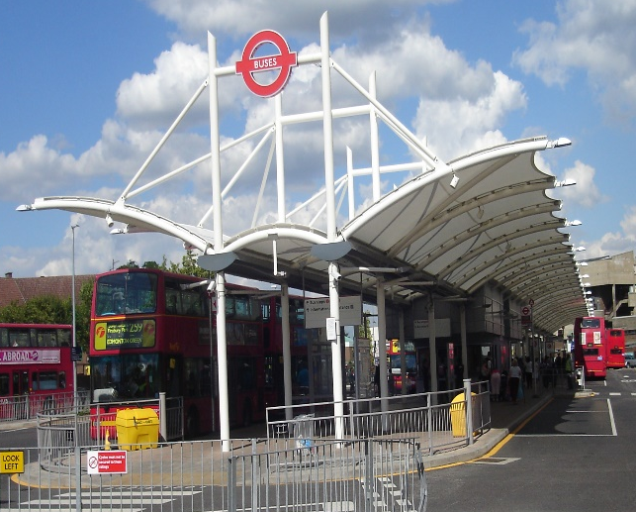

ENABLING INDEPENDENT TRAVEL

A service for people with learning disabilities and or Autism
Venue: Edmonton Green Bus Station
The first Thursday of every month
First session: 10:30am – 12noon
Second session:1pm – 2:30pm
Contact Claire Fenwick to place a booking: 020 8379 2450
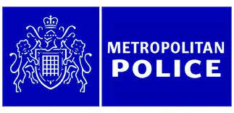
Email: Claire.Fenwick@enfield.gov.uk

