Anxiety & MH videoconference Q&A answers

How to deal with obsessive questions linked to an anxiety.
The first thing to do is to regulate ourselves, as this kind of questioning can feel irritating or overwhelming. So, as the adult, to ground ourselves, take a deep breath, or a moment before we answer. Give a clear answer to the question- or explain why you can’t- and then remind them that you have answered. It may help to create a visual or written answer that could go e.g. on the fridge. For some children, this kind of questioning is a ‘tell’ that they are feeling unsettled, anxious or overwhelmed- you could try to respond to the underlying emotion rather than the question itself e.g. use noticing and naming to say “It sounds like you’re feeling worried?”
Calmly say that you’re only going to answer 1-2 times, when they ask you the third time, ask them to tell you the answer, then re-direct to an activity or conversation that they prefer. Some will respond better if it’s a game or an interactive activity with you, or something physical if they need to regulate using motion. It can be really difficult for some YPs to accept this if they have got used to people responding repeatedly. Use visuals during a difficult incident and social stories when things are calm to prepare YP for how you will respond in future. Work with school to adopt the same approach for consistency.

Are there any techniques used by parents or teachers with EXPERIENCE when it comes to supporting our young people with extreme complex needs? We need actual techniques and support that works.
I’m assuming this question relates to anxiety issues. The techniques depend on the person and the reason for their anxiety. This is true of all problems so the advice could apply to other emotional difficulties in case this wasn’t about anxiety. Perhaps an approach like PBS can be helpful to understand the situations that your young person finds difficult and anxiety-provoking as well as the skills that they need to express their needs and learn coping skills (the anxiety management bit). It is very likely that your young person needs the skills of an MDT to ensure that their environment is ‘capable’ in helping them to feel safe and develop. The other factor is for you as parents and the teaching/support staff to be able to manage how overwhelming it can feel when faced with another person’s anxiety… Talk to school or GP about making a referral if you feel that you need more expert advice.

What has UK Government offered or done to help pupils with anxieties, which became very obvious during lockdowns?
Responding from the perspective of what the Department for Education has done, they have focused on skilling up school staff and building capacity in schools to support wellbeing and mental health. This has included the Wellbeing for Education Return grant, which in Enfield we used to provide a two-term-long professional learning programme to all staff in schools, on a wide range of themes relating to wellbeing and mental health. By 2025, every school is asked to have a designed lead for mental health, and there will be training and support for that role. The roll out of the Mental Health Support Teams continues- this is a national strategy to improve access to early intervention and support for mental health via schools.
How to differentiate between normal age-related behaviour and behaviour caused by anxiety?
For all of our children (and ourselves!), our resilience fluctuates, and so might our developmental or emotional age. Whatever the cause of the behaviour, the key question is what would be helpful. When our children are wobbly, going back to basics (including treating them as we would a younger child) can be a really helpful idea. Zoe and Sarah talked in their presentation about how to reduce a child’s vulnerability to strong emotions by addressing their sleep, eating, exercise etc.- and this is a good idea for us as adults too. If you think that your child might be experiencing worry or anxiety, start to look out for signs and patterns (can you predict what the triggers are?). If you become concerned about your child’s mental health, do speak to their school or GP, or seek advice from a local or national support organisation.
How do you address Anxiety which has led to school avoidance? What we could ask teachers to do to support a child who is feeling very anxious about going into school, especially after such a stop/ start year
As we heard in the presentation, avoidance is a completely natural response to anxiety. In the short term, it works to reduce anxiety. But in the medium and long term, our anxiety increases as the thing we’ve been avoiding grows bigger and scarier in our minds. The conventional wisdom for emotionally based school avoidance is to support children to return to school as quickly as possible, so that their avoidance doesn’t become entrenched, and they realise that the situation isn’t as bad as they have feared. Taking a trauma-informed approach, we know that it’s vital to address any triggers or distressing events that have happened in school, because we shouldn’t ask children to return to a situation that is unbearable- or which is as bad as they fear. The key here is to work with your child’s school at a very early stage, including being open with the school about why your child isn’t attending. Partnership is really key.
We would ask teachers and other school staff to do what we know works well for transition: preparing the child well, by making the school day predictable and letting them know what they can expect (this could involve a visual timetable); making a personal connection with the child and welcoming them in; allowing additional space and time for the child at the start and end of the day, and perhaps at transition points throughout the day; preparing the child for any changes; letting the child know who they can go to if they are feeling overwhelmed, and how to communicate this (e.g. using a traffic light system); working closely with the child’s parents or carers to identify what anxiety looks like for your specific child- what are the initial signs; what are the signs that it’s escalating, and what works well at each stage?
How are resources and approaches such as CBT or the apps available being made accessible for young people with a learning disability?
There are no apps offering adapted CBT for children and young people with Learning Disabilities that we can find. There are a number of Apps for children (on App Store) looking at anxiety. Lumi Nova an adventure game about overcoming fears. There’s a cute interactive book called ‘Little and Brave’ aimed at children aged 5-8 years.

CBT is difficult for children and young people with Learning Difficulties or Autism as it requires us to analyse thoughts in order to reflect on the links with feelings and then do things differently. Mental flexibility is needed, and this can be difficult at any age for neurodiverse people but is most difficult for children. Often the adapted form is really behavioural therapy, so missing out the cognitive part, but this still has a huge literature supporting it as an effective approach. Adaptations of CBT for younger children would be effective for some children.

What would be future symptoms within young teenagers, who went through anxiety episodes, but chose to refuse help? How could a parent help them, if they don't want to be seen by specialists (CAMHS)?
Try not to worry too much as a parent if your young person does not want to accept help from outsiders - remember people have been coping with anxiety for centuries and professionals (as we know them now) have only been around for a short amount of this time. It doesn’t mean that they don’t want ANY help and it doesn’t mean that they will go on to have lifelong mental health problems. Find out who they do want to talk to and why they don’t want to talk to someone outside of their circle of trust, if they can/will communicate this. It is more important to allow them choice and control so that they can access the right support for them and at a time when they are ready. We know that lots of CYP aren’t ready for psychological input until they are older teenagers. Prepare yourself by reading books and websites about how you can support your YP and ‘drip-feed’ helpful ideas and strategies, which school can also do. Have a look at Young Minds website and at books like ‘The huge bag of worries’ (aimed at 4-7 years) ‘What to do when you worry too much’ (8-11 years) ‘Starving the anxiety gremlin’ or ‘The anxiety survival guide for teens’ (12+ years).

How to best support a teenager who is self-harming and is not able to express why
Depends on whether this is in a young person who has learning difficulties or a more intellectually able young person. If more cognitively able, more likely to be self-harm. If more cognitively impaired, more likely to be self-injury.
Self-harm
Start with active listening. Listen closely and with great attention and interest. Don’t problem solve or try to challenge their ideas. Hear and accept that this is their reality first to acknowledge their distress. Ask them what they would like to be different and problem solve with them. Support them to request change or do this on their behalf if they cannot. Be prepared to change aspects of your own behaviour if relevant. Talk about alternative ways that they could express their distress that are less harmful and encourage them to use them. Try not to become too distressed yourself and seek emotional support for yourself and their other parent if involved.
Self-harm has become increasingly common in the past decade - no one knows why - but very few YPs will use this as a coping mechanism over the long term.
See this handout for parents: https://www.psych.ox.ac.uk/files/research/coping-with-self-harm-brochure_final_copyright.pdf
Self-injury
Positive Behaviour Support assessment to determine the reason (‘function’) of the self-injury. Try to observe when/where/what the young person is doing when they do their self-injury and what happens afterwards. Have a look at this handout: https://www.challengingbehaviour.org.uk/understanding-challenging-behaviour/specific-behaviours/self-injurious-behaviour/
Sibling rivalry. Both siblings have Asperger’s Syndrome, and are very competitive and argumentative.
If your children are able to get on some of the time, and depending on their age, is it possible for them to have a conversation about this when they are calm? If so, you could recruit them into agreeing the plan in advance for when they don’t get on. They will need your help to define this, but you could call a family meeting (including their father/your partner/grandparents or family who support them regularly) to discuss the issues. Set ground rules for this meeting - no shouting, everyone’s views are listened to etc. Then there is an agreement to refer back to in a big argument.
If your children are not old enough for this or they become too dysregulated and angry about past grievances, it requires ongoing parental management and intervention. This doesn’t mean that you would need to be omnipresent all of the time, but it will mean being their referee. Try not to get drawn into their argument or take sides - irrespective of merit. Usually it is both who have caused the argument using different strategies to wind each other up! Separate them for long enough to calm down and try to help them to make amends. Some children really don’t get on with their siblings, which is understandably heart breaking for parents, but also have patience that they might get on better in the future and allow them plenty of time apart. Have at least one family activity per week that you all do together and everyone this to hold onto the sense of unity within the family. Also, it’s very important to have 1:1 special time with each child as they may be fighting over your attention.

How can you support an anxious child if you are suffering from anxiety yourself?
The principles explained in the presentation apply equally well to adults, so do try to work through the steps to overcoming anxiety- it would be great modelling for your child to observe you overcoming your own worries and fears. Try to practise responding to your child in a confident way about their worries and fears (even if you don’t feel confident inside). You can refer yourself to adult IAPT services in your local area for support with anxiety.
How to you help a child with a phobia about vomiting, given that it isn’t possible to control when this occurs, and it is therefore difficult to have graduated exposure?
This resource shows an approach to this problem: https://emetophobiahelp.org/exposure-resources-for-kids/

Additional support and resources

Our Voice page on Anxiety and Mental Health
The OV website page on anxiety and mental health pulls together a range of resources relevant to children with SEND: OurVoice (ourvoiceenfield.org.uk) this includes the set of videos produced by OV/EPS/CAMHS together
EPS helpline
See attached flyer. Access the online form here.
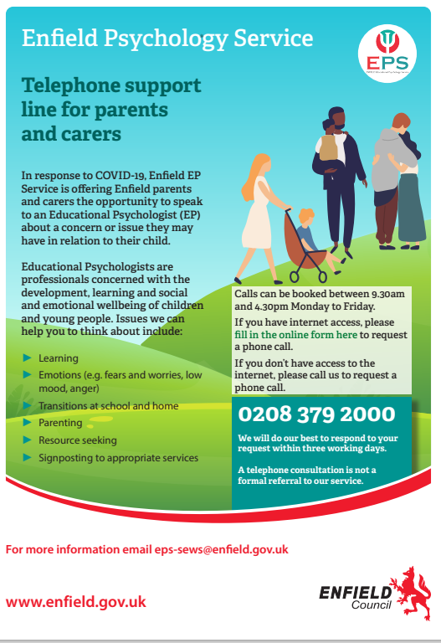
Extra support/resources • Enfield CAMHS 24/7 – crisis line 08001510023
Enfield IAPT – Free adult counselling sessions
Headspace App – free meditation and mindfulness
SENDIASS– SEN support service 07903 762008
IPSEA – Independent panel for SEN provides free legal advice and helpline ipsea.org.uk
FamilyAction – family/parent helpline 0808 802 6666

